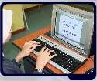
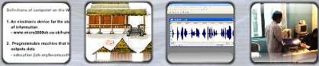
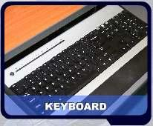
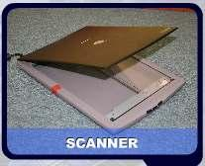
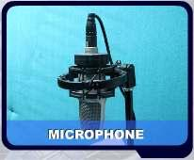

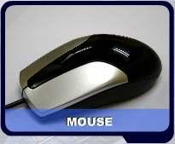
LESSON 34
INPUT DEVICES

INPUT
Input is any data or instruction that you enter into
the memory of a computer.

There are four types of input: which are text,
graphic, audio and video.

INPUT DEVICES
M. Amin, SMK Raja Shahriman

Input devices are any electronic device connected to a computer and
produces input signals.

A keyboard is an example of input
device for text input.

A scanner is an example of input
device for graphical as well as text
input.

A microphone is an example of
input device for audio input and a
webcam is an example of an
input device for video input.

A mouse is also an input device but it is called a
pointing device used to input data that is continuous
and multi-dimensional into a computer.

83

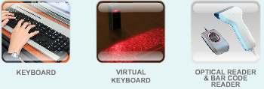
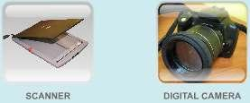
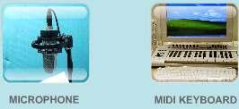
a) INPUT DEVICES FOR TEXTS
M. Amin, SMK Raja Shahriman

You can enter data such as text and commands into a computer by pressing
the keys on the keyboard.

You can press the keys of a virtual keyboard on the screen.

An optical reader is a device that uses a light source to read characters,
marks and codes and then converts them into digital data that a computer
can process.

b) INPUT DEVICES FOR GRAPHICS

A scanner is a device that captures images from photographic prints,
posters, magazine pages and similar sources for computer editing and
display.

A digital camera allows you to take pictures and store the photographed
images digitally.

c) INPUT DEVICES FOR AUDIO

Audio input is the speech, music and sound effects entered into the
computer. This can be done using input devices such as a microphone and
digital musical instruments like the Musical Instrument Digital Interface
(MIDI) keyboard.

84

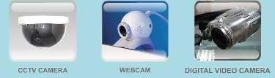
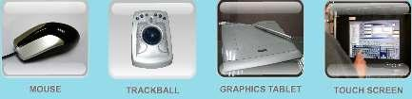
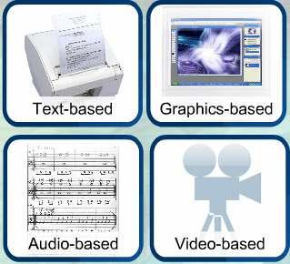
d) INPUT DEVICES FOR VIDEO
M. Amin, SMK Raja Shahriman

Video input is input of motion images captured into the computer by special
input devices.

A Closed-Circuit Television (CCTV) video camera is a type of digital video
camera that enables a home or small business user to capture video and still
images.

A webcam is any video camera that displays its output on a web page.

A digital video camera allows you to record full motion and store the
captured motion digitally.

e) POINTING DEVICES

A pointing device is another form of input device. Pointing devices such as a
mouse, trackball, graphics tablet and touch screen are used to input
spatial data into the computer.

Spatial data refers to data that is continuous and multi-dimensional.

LESSON 35
OUTPUT DEVICES

Output is the result of data processing
activity when it is presented external to the
system.

The output from a computer can be in a form
for use by people, for example, printed or
displayed. There are four types of output,
which are:

85

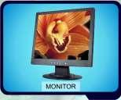
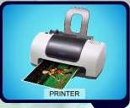
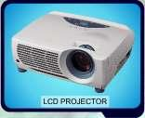
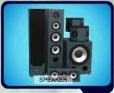
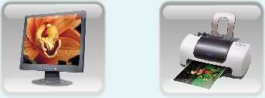
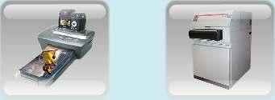

OUTPUT DEVICES
M. Amin, SMK Raja Shahriman

An output device is hardware that is capable of delivering or showing
information to one or more users. An output device shows, prints and
presents the results of a computer’s work.

TYPES OF OUTPUT DEVICES

A display device is an output device that visually conveys texts, graphics
and video information. A printer is an output device that prints text and
graphics on a physical medium such as paper or transparency film.An audio
output device produces music, speech, or other sounds.

Other output devices include Liquid Crystal Display (LCD) projectors and
facsimile (fax) machines.

A monitor is an example of an output device that can be used to display
text. It can also display graphics and video. It is similar to a television set
that accepts video signals from a computer and displays information on its
screen.

A printer is another example of an output device that can be used to print
text, apart from graphics, on mediums such as paper, transparency film or
even cloths.

A photo printer is a colour printer that produces photo-lab-quality pictures.
86

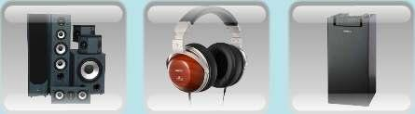
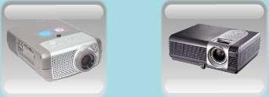
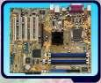
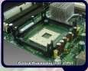
M. Amin, SMK Raja Shahriman
An image setter produces high quality output compared to an ordinary laser
printer. An image setter is a high resolution output device that can transfer
electronic text and graphics directly to film, plates, or photo-sensitive paper.

A pair of speakers is an audio output device that generates sound. The
headphone is a pair of small speakers placed over the ears and plugged into
a port on the sound card. A woofer or subwoofer is used to boost the low
bass sound and is connected to the port on the sound card.

A Liquid Crystal Display (LCD) projector uses its own light source to project
what is displayed on the computer on a wall or projection screen. A digital
light processing (DLP) projector uses tiny mirrors to reflect light which can
be seen clearly in a well-lit room.

LESSON 36
MOTHERBOARD

This is a motherboard and its components. Motherboard
is the main circuit board of the system unit, which has
some electronic components attached to it and others
built into it.

This is the location of the Central Processing Unit (CPU).

87
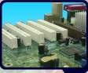
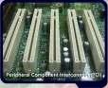
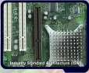
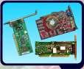
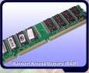
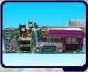
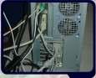
M. Amin, SMK Raja Shahriman

This is where the expansion slots are located.

These are the Peripheral Component Interconnect (PCI)
expansion slots.Peripheral Component Interconnect. A
personal computer local bus which runs at 33 MHz and
supports Plug and Play. It provides a high-speed
connection with peripherals and allows connection of
seven peripheral devices

In addition, the Industry Standard Architecture (ISA)
expansion slots are also the components of the
motherboard.Industry Standard Architecture. A PC
expansion bus used for modems, video displays,
speakers, and other peripherals.PCs with ISA commonly
have some 8-bit and some 16-bit expansion slots.

These are the expansion card.The expansion cards are
slotted in the expansion slots.

This is called RAM or Random Access Memory. RAM is
the memory of the computer.

This is the location of the ports. Connectors are plugged
into these ports. Port is Point at which peripheral
attaches to a system unit so it can send data to or
receive information from the computer.

The connector connects to the port. For example, the
printer port matches its connector. All computer
components are connected to its respective ports by a
connector.

88

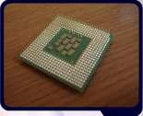
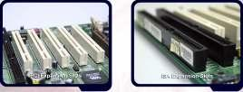
LESSON 37
COMPONENTS OF A MOTHERBOARD

CENTRAL PROCESSING UNIT (CPU)
M. Amin, SMK Raja Shahriman

The Central Processing Unit (CPU) controls the operation
of the computer. It interprets and carries out the basic
instructions that operate a computer. The processor
significantly impacts overall computing power and
manages most of a computer's operations.

On larger computers such as mainframes and supercomputers, the various
functions performed by the processor extend over many separate chips and
often multiple circuit boards.

On personal computer, all functions of the processor usually are on a single
chip. Some computers and chip manufacturers use the term microprocessor
to refer to a personal computer processor chip.

EXPANSION SLOTS

Expansion slots are the sockets where the circuit boards or the adapter
cards can be inserted into the motherboard. In computers, a slot or
expansion slot, is an engineered technique for adding capability to a
computer in the form of connection pinholes (typically in the range of 16 to
64 closely-spaced holes).

It is a place to fit an expansion card containing the circuitry that provides
some specialised capability, such as video acceleration, sound or disk drive
control.

A Peripheral Component Interconnect (PCI) bus is a high speed expansion
bus that connects high speed devices.

An Industry-Standard Architecture (ISA) expansion slot is a slot in a
computer where ISA accessories can be added to.

89

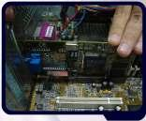
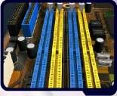
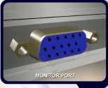

EXPANSION CARDS
M. Amin, SMK Raja Shahriman

An expansion card is plugged into an expansion slot. It is used to add new
devices or capabilities to a computer.

An expansion card is a circuitry designed to provide
expanded capability to a computer. It is provided on the
surface of a standard-sized rigid material (fiberboard)
and then plugged into one of the computer's expansion
slots in its motherboard (backplane).

Cards may come in one of two sizes designed to match standard slot
dimensions. Cards may come in one of two sizes designed to match standard
slot dimensions.

RAM SLOT

The slot where the computer memory, also called as
RAM is placed on the computer’s motherboard.

PORTS AND CONNECTORS

A port is the point at which a peripheral attaches to a
system unit so that the peripheral can send data to or
receive information from the computer.

An external device, such as a keyboard, monitor,
printer, mouse and microphone is often attached by a
cable to a port on the system unit.

The back of the system unit contains so many ports. Some newer personal
computers also have ports on the front of the system unit.

Ports have different types of connectors. A connector joins a cable to a
peripheral. One end of a cable attaches to the connector on the system unit
and the other end of the cable attaches to a connector on the peripheral.

90

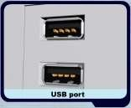
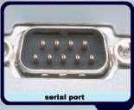
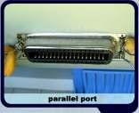
LESSON 38
PORTS AND CONNECTORS
M. Amin, SMK Raja Shahriman

There are different kinds of port in a system unit. The
ports are :
Serial port
Parallel port
Universal Serial Bus (USB) port.
FireWire port

special purpose ports

- MIDI port
- SCSI port
- IrDA port

1) SERIAL PORT

A serial port is a socket on a computer used to connect
a modem, data acquisition terminal or other serial
devices via a slow-speed serial interface.

A serial port is used to connect a device to the system
unit by transmitting data one bit at a time.

Earlier PCs used the serial port for the mouse, and earlier Macintosh models
used the serial port to attach a printer.

Today, the serial port is a legacy interface, having been superseded by the
USB bus. An example of a serial port is the COM (communication) port.

2) PARALLEL PORT
A parallel port is a socket on a computer used to connect a printer or other
parallel devices via the computer's parallel interface.

Unlike a serial port, a parallel port is an interface that
connects devices by transferring information more than
one bit at a time. Originally, parallel ports were
developed as an alternative to the slower speed serial
ports. Many printers connect to the system unit using a
parallel port.

This parallel port can transfer eight bits of data (one byte) simultaneously
through eight separate lines in a single cable. An example of a parallel port
is the printer port.

91

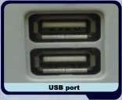
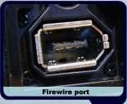
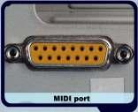
3) USB PORT
M. Amin, SMK Raja Shahriman

A USB port is a socket on a computer or peripheral
devices into which a USB cable is plugged in. A USB
port, short for universal serial bus port, can connect up
to 127 different peripherals together with a single
connector.

It's used to connect all kinds of external devices, such as external hard
drives, printers, mouse and scanner. It can transfer data to a speed of 12
megabits per second.

USB ports began to appear on PCs in 1997, and Windows 98 was the
first Windows to support it. Within a few years, the USB became popular
for connecting nearly every external peripheral device. Now that it is
replacing the serial and parallel ports on a PC, at least four USB ports are
standard on every computer.

4) USB PORT

Previously the FireWire port is called IEEE 1394 port, a personal computer
(and digital audio/video) serial bus interface standard.

FireWire is similar to a USB port in that it can connect
multiple types of devices that require faster data
transmission speeds. Usually camcorders and other
video equipment use this port to transmit data on a
computer. Data can move across the port at up to 400
megabits per second.

Apple invented this technology and had branded it as FireWire. It was also
adopted as an industry standard and is called IEEE 1394 on non-Apple
computers. Up to 63 devices can be daisy-chained to one FireWire port.

Daisy-Chain
A bus wiring scheme in which, for example, device A is wired to device B,
device B is wired to device C, device C to device D etc.

5) SPECIAL PURPOSE PORTS
There are four special purpose ports, which are:

MIDI port
It is designed to connect the system unit to a musical
instrument, such as an electronic keyboard.

92

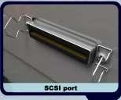
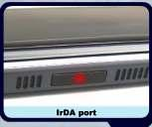
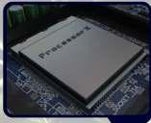

SCSI port
It is a special high-speed parallel port used to attach
peripheral devices such as disk drives and printers..

IrDA port
Some devices transmit data via infrared light waves.
For these wireless devices to transmit signals to a
computer, both the computer and the device must
have an IrDA port.

LESSON 39
CENTRAL PROCESSING UNIT
M. Amin, SMK Raja Shahriman

Like human beings, computers too have a ‘brain’ that processes raw
information into usable data. Users input data into the computer system and
it is then processed by the central processing unit or the CPU. The results of
the processed data are then sent to an output device as usable data.

THE CENTRAL PROCESSING UNIT (CPU)

A Central Processing Unit or CPU is a microprocessor
(or processor for short). It is an integrated circuit chip
that is capable of processing electronic signals. The CPU
is the most important element in a computer system.

A CPU interprets instructions given by the software and carries out those
instructions by processing data and controlling the rest of the computer’s
components.

Nowadays, processors are found in all kinds of electronic devices such as cell
phones, calculators, automobile engines, and even industrial and medical
equipment. They process information so that humans can enjoy their
effective and efficient operation.

A CPU consists of two subcomponents; the Control Unit (CU) and the
Arithmetic Logic Unit (ALU).

93

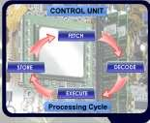
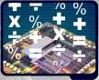
1) CONTROL UNIT (CU)
M. Amin, SMK Raja Shahriman

Basically the Control Unit’s main function is to direct the
CPU to process data. The Control Unit extracts
instructions from memory and decodes and executes
them.

Under the direction of a program, the Control Unit manages a four-step
basic operation which is called a machine cycle or processing cycle.

Fetch and decode is in the instruction cycle whereas execute and store is in
the execution cycle. Today’s microprocessor can go through this entire
four-step process billions of times per second.

FETCH
Retrieves the next program instruction from the computer’s memory.

DECODE
Determines what the program is telling the computer to do.

STORE
Stores the results to an internal register (a temporary storage location or to
memory).

EXECUTE
Performs the requested instruction, such as adding two numbers or deciding
which one of them is larger.

2) ARITHMETIC LOGIC UNIT (ALU)

The Arithmetic Logic Unit (ALU), as its name implies,
can perform all arithmetic and logical operations.
Arithmetic operation is an operation that forms a
function of two numbers. This function is usually one of
the class of operations: add, subtract, multiply and
divide.

Logic operation is an operation on logical values, producing a Boolean result.
In general there are 16 logic operations over one or two operands; they
include AND, OR, NOT, NAND, NOR, XOR and equivalence.

94

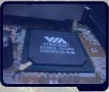
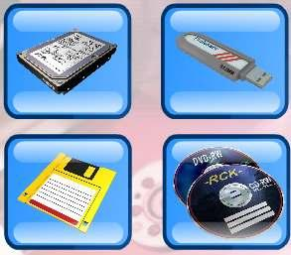
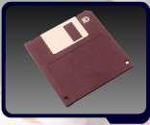
M. Amin, SMK Raja Shahriman
HOW DATA IS PROCESSED BY THE CPU

When a user starts a program, its instructions are
transferred from the storage device to the memory. The
user enters the data needed by the program.

The Control Unit then interprets and executes instructions in the memory.
The Arithmetic Logic Unit then performs calculations on the data in the
memory. As a result, information is then stored in the memory. Information
can then be sent to an output device or a storage device.

LESSON 40
STORAGE

WHAT IS COMPUTER
STORAGE ?

Information and documents are stored
in computer storage so that it can be
retrieved whenever they are needed
later on.

Computer storage is the holding of
data in an electromagnetic form for
access by a computer processor.

FUNCTIONS OF COMPUTER STORAGE.

Computer storage is important to help users store
programs and data to be used at a later time.

It is also useful to keep current data while being
processed by the processor until the information is saved
in a storage media such as a hard disk or a diskette.
Computer storage also stores instructions from a
computer program.

95

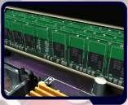
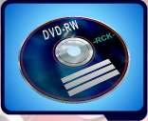
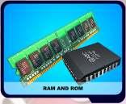
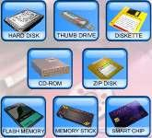
TYPES OF COMPUTER STORAGE
M. Amin, SMK Raja Shahriman

Primary storage is known as the main memory of a
computer, including RAM (Random-Access Memory)
and ROM (Read-Only Memory). It is an internal
memory (inside the CPU) that can be accessed directly
by the processor.

Secondary storage is the alternative storage in a
computer. It is an external storage that refers to
various ways a computer can store program and data.

PRIMARY STORAGE
Primary storage is installed internally. Two main types
of primary storage are RAM and ROM.

Data from RAM can be read or retrieved and written or
stored during processing whereas data from ROM can
just be read only.

RAM is volatile, which means the program and data will be lost when the
computer is turned off.

ROM is non-volatile which means it holds the programs and data even when
the computer is turned off.

Many complex functions, such as translators for high-level languages and
operating systems are placed in primary storage.

volatile : The content is lost when a computer’s power is turned off.

SECONDARY STORAGE
Secondary storage is an alternative storage. It is
very useful to store programs and data for future
use. Secondary storage is required for two
reasons.

1. The working memory of the CPU is limited
in size and cannot always hold the amount
of data required.

2. Data and programs in secondary storage do not disappear when the
power is turned off.

96

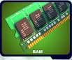
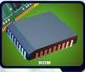
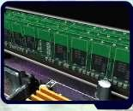
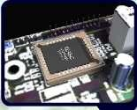
LESSON 41
PRIMARY STORAGE
M. Amin, SMK Raja Shahriman

Primary storage is the main memory in a computer. It stores data and
programs that can be accessed directly by the processor.

TYPES OF PRIMARY STORAGE
There are two types of primary storage which are RAM and ROM.

RAM is an acronym for Random-Access Memory which
means the data and program in RAM can be read and
written.

ROM is an acronym for Read-Only Memory. The data or
program in ROM can just be read but cannot be written at
all.

RANDOM-ACCESS MEMORY (RAM)

RAM is installed inside computers. RAM is also
known as a working memory.
The data in RAM can be read (retrieved) or
written (stored).
RAM is volatile which means the programs and
data in RAM are lost when the computer is
powered off.
A computer uses RAM to hold temporary instructions and data needed
to complete tasks. This enables the computer's CPU (Central
Processing Unit) to access instructions and data stored in the memory
very quickly.
RAM stores data during and after processing.

READ-ONLY MEMORY (ROM)
ROM is another type of memory permanently
stored inside the computer.
ROM is non-volatile. It holds the programs and
data when the computer is powered off.
Programs in ROM have been pre-recorded. It can
only be stored by the manufacturer; once it is
done, it cannot be changed.
Many complex functions, such as start up operating instructions,
translators for high-level languages and operating systems are placed
in ROM memory.
All the contents in ROM can be accessed and read but cannot be
changed.
97

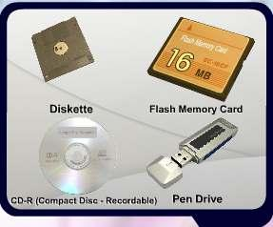
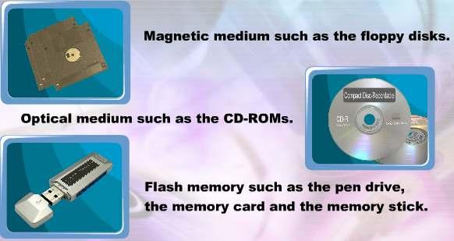
M. Amin, SMK Raja Shahriman
DIFFERENCES BETWEEN RAM AND ROM

Data and
program
Content

RAM
Stores during and after
processing
Stores information
temporarily

ROM
Stored by manufacturer

Stores instructions
(Information) permanently

Processing time Very fast, but uses a lot Fast, but uses very little

Volatility

LESSON 42
of power
Volatile
power
Non-volatile

SECONDARY STORAGE

WHAT IS SECONDARY STORAGE?

Secondary storage is another
alternative storage to keep your work
and documents. It is very useful to
store programs and data for future use.

It is non-volatile, which means that
it does not need power to maintain
the information stored in it. It will
store the information until it is erased.

TYPES OF SECONDARY STORAGE

98

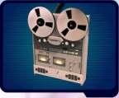
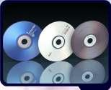
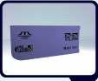
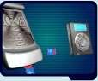
MAGNETIC MEDIUM
Magnetic Medium is a non-volatile storage medium.
It can be any type of storage medium that utilizes
magnetic patterns to represent information.

The devices use disks that are coated with
magnetically sensitive material. The examples of
magnetic storage are:

magnetic disk such as:
o a floppy disk, used for off-line storage
o hard disk, used for secondary storage
M. Amin, SMK Raja Shahriman

magnetic tape; including video cassette, audio storage reel-to-reel
tape and others.

OPTICAL MEDIUM
Optical Medium is a non-volatile storage media that
holds content in digital form that are written and read
by a laser. These media include various types of CDs
and DVDs.

These following forms are often commonly used :

CD, CD-ROM, and DVD: Read only storage, used for distribution of
digital information such as music, video and computer programs.
CD-R: Write once storage, the data cannot be erased or written over
once it is saved.
CD-RW, DVD-RW, and DVD-RAM: Slow to write but fast reading
storage; it allows data that have been saved to be erased and
rewritten.

Optical media have a number of advantages over magnetic media such as
the disk capacity. One optical disk holds about the equivalent of 500 floppy
disks worth of data. Durability is another feature of optical media, they are
able to last for up to seven times as long as traditional storage media.

FLASH MEMORY
Flash Memory is a solid-state, non-volatile, rewritable
memory that functions like RAM and a hard disk drive
combined. Flash memory store bits of electronic data in
memory cells just like DRAM (Dynamic RAM), but it also
works like a hard disk drive that when the power is
turned off, the data remains in the memory. Flash
memory cards and flash memory sticks are examples of
flash memory.

Flash memory cards are also used with digital cellular
phones, MP3 players, digital video cameras and other
portable digital devices.

99

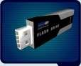
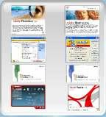
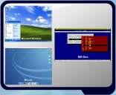
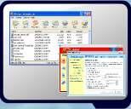
M. Amin, SMK Raja Shahriman

Flash memory is also called USB drives, thumb drives, pen drives or flash
drives, are the up-and-coming players in the portable storage market.

The advantages of flash memory are, it offers fast
reading access times among the secondary storage
devices, (though not as fast as RAM) it is durable and
requires low voltage. It is also light and small. The
disadvantage is, it is more expensive than the magnetic
disk of the same capacity.

LESSON 43
TYPES OF SOFTWARE

Software is a program which consists of a set of
instructions that tells the computer how to perform
a specific operation.

A computer is just a machine with no special
benefits without software.

CATEGORIES OF SOFTWARE
Software can be divided into two categories, which
are:

System Software
Software that is used to control and manage computer devices and
operations.

Application Software
Software that is used to help a user perform a task and solve a problem.

SYSTEM SOFTWARE
System software refers to all programs that help the
computer to function properly. The most important
type of system software is the computer’s operating
system, which enables the computer to start, such as
Microsoft Windows, MS-DOS and Mac OS.

Other types of system software include system utilities
such as file compression (zip program) and antivirus
programs.

100

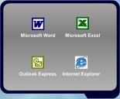
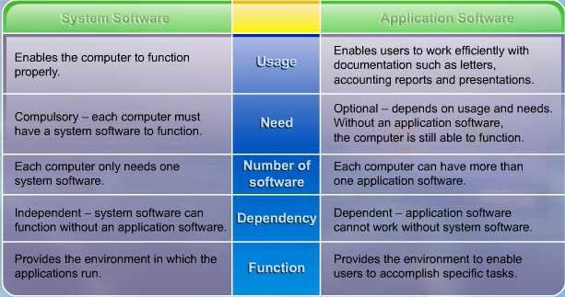
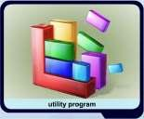
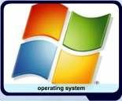
APPLICATION SOFTWARE
Application software are all programs that perform
specific tasks for users, which include word
processing, spreadsheet, database, presentation
e-Mail and Web browser software. Examples of
application software are Microsoft Word, Microsoft
Excel, Outlook Express and Internet Explorer.
M. Amin, SMK Raja Shahriman

SYSTEM SOFTWARE VS APPLICATION SOFTWARE

The differences between system software and application software.

LESSON 44
SYSTEM SOFTWARE

WHAT IS SYSTEM SOFTWARE
A system software is a program that controls or maintains the operations of
a computer and its devices. A system software also serves as the interface
between the user, the application software and the computer’s hardware.

101

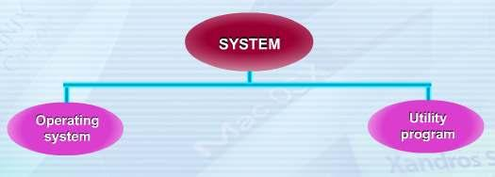
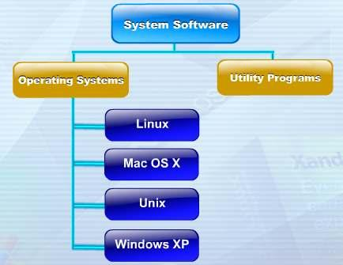
There are two types of system software:
• operating system
• utility program

OPERATING SYSTEM
M. Amin, SMK Raja Shahriman

An operating system is a set of programs that coordinates all the activities
among the computer hardware devices. In most cases, the operating system
is installed and resides on the computer’s hard disk.

However, on handheld computers and many mobile devices such as PDAs
and smart phones, the operating system may reside on a ROM chip.

The operating system that a computer uses sometimes is called the
platform.

102

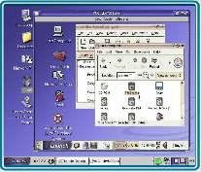
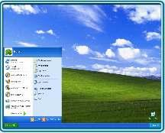
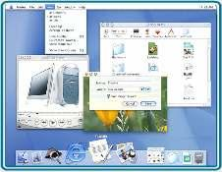
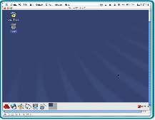
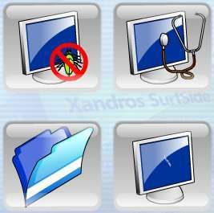

Linux is a freely distributed UNIX, it is a compatible
operating system for PCs and a number of other
processors.

Mac OS X is a multitasking operating system that is
the latest version of the Macintosh operating system.

UNIX is an operating system, or family of operating
systems, developed at Bell Laboratories in early
1970sas a replacement for an earlier system called
Multics.

Windows XP is the latest version of the Windows
operating system, which is Microsoft’s fastest, most
reliable Windows operating system.

UTILITY PROGRAM
M. Amin, SMK Raja Shahriman

A utility program which is also called a utility is a type of system software
that allows a user to perform maintenance-type tasks usually related to
managing a computer, its devices or its programs.

Antivirus

File Manager

103

Diagnostic Utility

Screen Savers

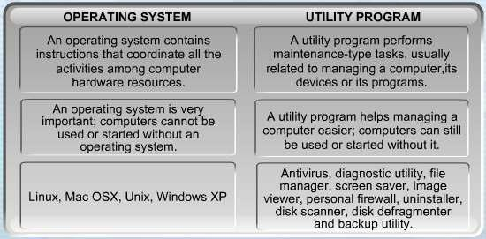
ANTIVIRUS
M. Amin, SMK Raja Shahriman

Antivirus is a program that protects a computer against viruses by
identifying and removing any computer viruses found in a memory or
storage media or in incoming files.

DIAGNOSTIC UTILITY
Diagnostic utility is a utility program that compiles technical information
about a computer’s hardware and certain system software programs and
then prepares a report outlining any identified problems.

FILE MANAGER
File manager is a utility program that performs functions related to files and
disk management.

SCREEN SAVER
Screen saver is a utility program that enables a display device’s screen to
show a moving image or blank screen if no mouse activity occurs for a
specified time.

THE DIFFERENCES BETWEEN OPERATING SYSTEMS
AND UTILITY PROGRAM

104

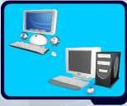
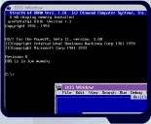
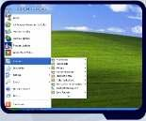
LESSON 45
TYPES OF OPERATING SYSTEMS
M. Amin, SMK Raja Shahriman

DEFINITION OF OPERATING SYSTEM
An operating system is a set of programs that schedule tasks, allocates
storage and presents a default interface to the user between applications.
Many of the first operating systems were device-dependent and proprietary.

The functions of the operating systems are:
starting a computer
providing a user interface
managing data and programs
managing memory
configuring devices

A device-dependent program is the one that runs only on a specific make of
a computer.

Proprietary software is privately owned and limited to a specific vendor or
computer.

PC PLATFORM OPERATING SYSTEMS
There are various types of operating system used on different platforms. The
examples of operating systems used on PC platforms or IBM compatible
computers are:
Disk Operating System (DOS)
Microsoft Windows XP

It is necessary for computer manufacturers to produce
unique software versions for each platform available in
the market. For instance, the Apple Macintosh, PC-
compatibles, and Sun SPARC-Stations are all different
platforms.

DOS is an acronym for Disk Operating System.
Microsoft developed DOS in the early 1980s for
personal computers. DOS used a command line
interface when Microsoft first developed it. It is a
closed source software.

Microsoft Windows XP’s operating environment is a
Graphical User Interface (GUI). It is a closed source
software.

105

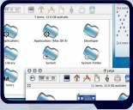
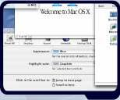
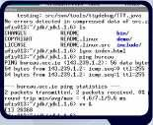
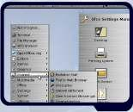
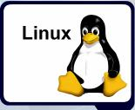
M. Amin, SMK Raja Shahriman
APPLE PLATFORM OPERATING SYSTEMS

The operating systems used on Apple platforms are:
Mac OS
Mac OS X

Mac OS was the first commercially successful graphical
user interface released in 1984. It is a closed source
software and are targeted for use with home desktops
and workstations.

Mac OS X is a multitasking operating system and it is
the latest version of the Macintosh operating system
released in 2001. Mac OS X is targeted for use with
home desktops, workstations and servers. It also has
better security protection compared to Mac OS, for
example the integrated firewall utility.

CROSS-PLATFORM OPERATING SYSTEMS
Cross-platforms operating systems are:
UNIX
LINUX

UNIX is a multitasking operating system developed in
the early 1970s by scientists at the Bell Laboratories.
Some versions of UNIX have a command line interface
but most versions of UNIX offer a graphical user
interface.

Linux is a popular, free, UNIX-like graphical user
interface operating system. It is an open source
software. Linux follows the Free Software Foundation's
radical licensing model, which provides a great deal of
liberty to those that interact with Linux technology.

Although Linux runs on many kinds of equipment, it is
best known for its support of IBM-Intel PC-based
hardware.

106

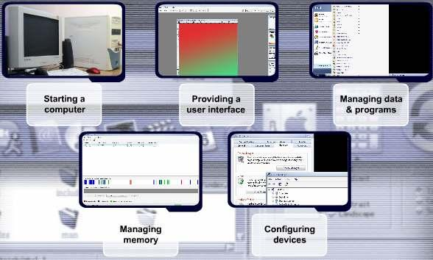
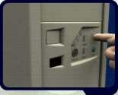
LESSON 46
FUNCTIONS OF OPERATING SYSTEMS
M. Amin, SMK Raja Shahriman

DEFINITION OF OPERATING SYSTEM
An operating system, also commonly called OS is a set of programs that
coordinates all the activities among computer hardware devices. It also
supports the application software that we run.

It is designed to work with a specific type of computer such as a PC or a
Macintosh. Examples of popular Operating Systems are:-
Disk Operating System (DOS)
Linux
Mac OS X
Unix
Windows XP

FUNCTIONS OF OPERATING SYSTEM

1) STARTING THE COMPUTER
The first function of an operating system is to start
the computer. When we start a computer, it loads the
operating system into the computer's memory. This
process is called booting. Booting means to load and
initialize the operating system on a computer
machine. It can happen in two ways: warm boot or
cold boot.

107

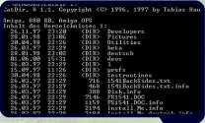
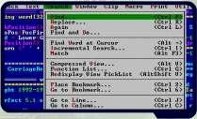
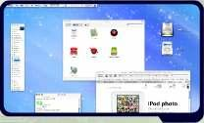
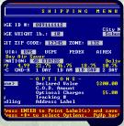
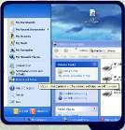
WARM BOOT
M. Amin, SMK Raja Shahriman

A warm boot means restarting a computer that is already on.It normally
happens after installing a new software or hardware or after an application
crashes or stops working.

COLD BOOT
A cold boot means starting a computer that is already off. It happens when
we turn on a computer that has been completely powered off.

2) PROVIDING A USER INTERFACE
From the user's perspective, the most important function of an operating
system, is providing the user interface. This function controls how the user
enters data and instruction and how information is displayed.

The user interface typically enables users:
to start an application program
to manage disks and files such as formatting, copying and renaming
to shut down the computer safely by following the correct procedures

The three types of user interface are Command-Line, Menu-Driven and
Graphical User Interface (GUI).

Command-Line

Menu-Driven

GUI

3) MANAGING DATA AND PROGRAMS
The next function of an operating system is to manage data and programs.
When we start an application, the CPU loads the application from storage
into memory.

In the early days of personal computing, single-tasking operating systems
could run only one application at a time.

Multitasking operating systems enable users to work with two or more
application programs at the same time.

108

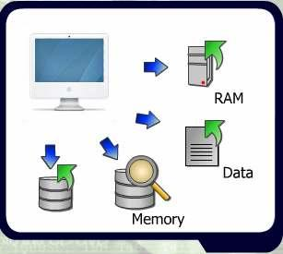
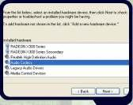
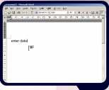
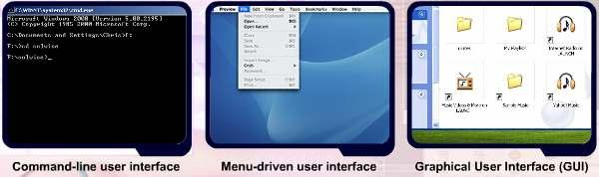
4) MANAGING MEMORY
M. Amin, SMK Raja Shahriman

The computer's operating system is responsible for managing memory such
as:
optimizing the use of random access
memory (RAM)
allocating data and instruction to an
area of memory while being
processed
monitoring the contents of memory
releasing data and instructions from
being monitored in memory when the
process is done

5) CONFIGURING DEVICES
Another function of an operating system is handling
input and output, as well as enabling communication
with input and output devices. Most operating
systems come with drivers for popular input and
output devices.

These drivers install new devices and check
whenever there is conflict with these devices.

LESSON 47
INTRODUCTION TO COMPUTER SYSTEM

THE IMPORTANCE OF USER INTERFACES
The user interface is the part of an operating system
that you see and interact with and by which users
and programs communicate with each other.

The importance of user interfaces are:
to assist users interacting with a software
to control how a user enters data and
instructions
to control how information is displayed

109

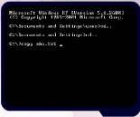
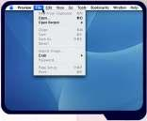
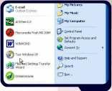
COMMAND-LINE USER INTERFACE
The command-line user interface requires a user to
type commands or press special keys on the
keyboard to enter data and instructions that instruct
the operating system what to do. It has to be typed
one line at a time.

The command-line user interface is difficult to use
M. Amin, SMK Raja Shahriman

because it requires exact spelling, syntax or a set of rules of entering
commands and punctuation.

We must observe the complicated rules of syntax that specify exactly what
you can type in a given place.For example, if we want to rename a filename
from ABC.txt to DEF.txt we use the following command.

The command-line user interface also requires memorisation. It is also easy
to make a typing mistake. The advantage of command-line interface is, it
helps the user to operate the computer quickly after memorizing the
keywords and syntax.

MENU DRIVEN INTERFACE
Menu-driven user interface enables the user to avoid
memorizing keywords such as copy, paste and
syntax. On-screen, menu-driven interface provide
menus as means of entering commands. It shows all
the options available at a given point in a form of
text-based menu. Menu-driven user interfaces are
easy to learn.

GRAPHICAL USER INTERFACE (GUI)
Graphical user interface makes use of the computer’s
graphics capabilities to make the operating system
and programs easier to use, which is also called
‘user-friendly’. On today’s PCs and Macintoshes, GUIs
are used to create the desktop that appears after the
operating system finishes loading into memory.

We can easily differentiate the interfaces between Mac OS, Windows XP or
Linux by looking at their desktops. Graphical user interface interact with
menus and visual images such as buttons, icons and other graphical objects
to issue commands.

On the desktop, we can initiate many actions by clicking icons that represent
computer resources such as files, programs and network connections.
Graphical user interface is commonly used and has become a standard.

110

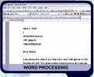
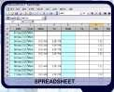
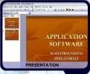
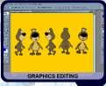
LESSON 48
TYPES OF APPLICATION SOFTWARE
M. Amin, SMK Raja Shahriman

DEFINITION OF APPLICATION SOFTWARE
Application software is a computer program or a suite of computer
programs that performs a particular function for the user. Application
software includes all programs that perform specific tasks such as word
processing, spreadsheet, database, presentation, e-mail and Web browsing

A software application that enables a user to display and interact with text,
images, and other information typically located on a web page at a website
on the World Wide Web.

TYPES OF APPLICATION SOFTWARE

COMMON TYPES OF APPLICATION SOFTWARE

Word Processing
Word Processing an office application that enables user to create, edit,
format and print textual document.

Spreadsheet
A program that processes information in the form of tables. Tables cells can
hold values or mathematical formula.

Presentation
An application software that allows a user to create visual aid for
presentation to communicate ideas, messages and other information to a
group.

Graphics Editing
Program that can edit digital representation or non-text information such as
drawing, charts and photograph.

111

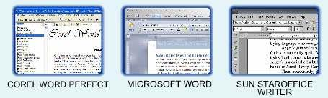
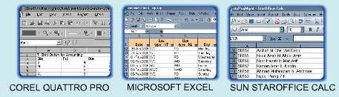
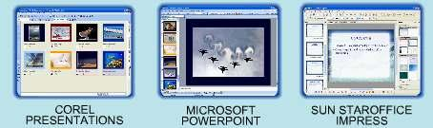
1)WORD PROCESSING
M. Amin, SMK Raja Shahriman

A word processing program is an office application that enables users to
create, edit, format and print textual documents. It also offers commands
that enables users to format a document so that they can create an
attractive appearance.

2) SPREADSHEET
A spreadsheet is a program that processes information in the form of grid of
columns and rows. It is also called a table. Table cells can hold values or
mathematical formulas. Spreadsheets are indispensable tools for anyone
who works with numbers.

3) PRESENTATION
A presentation software enables users to create transparencies, slides and
handouts for presentation. It allows a user to create visual aids for
presentation to communicate ideas, messages and other information to a
group.

112

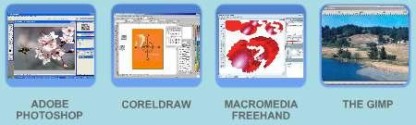
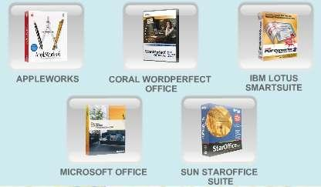
4) GRAPHICS EDITING
M. Amin, SMK Raja Shahriman

Graphics editing is a program that can edit digital representation or non-text
information such as drawings, charts or photographs.

SOFTWARE SUITE
A software suite is a collection of individual programs sold as a single
package. The software suite is designed to enhance the performance of our
work. It typically includes word processing, spreadsheet, presentation and e-
mail. Currently, Microsoft Office is a very popular example of software suite
being used.

EXAMPLES OF SOFTWARE SUITES

113

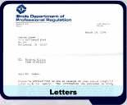
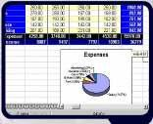
LESSON 49
USAGES OF APPLICATION SOFTWARE
M. Amin, SMK Raja Shahriman

USAGES OF WORD PROCESSING SOFTWARE
A word processing software (word processor) allows
users to create and manipulate documents
containing mostly text and sometimes graphics.

It provides the ability to create, check spelling, edit
and format a document on the screen before printing
it to paper.

A word processing software can be used to produce documents such as
letters, memos, reports, fax cover sheets, mailing labels, newsletters, and
web pages. Examples of word processing software are Microsoft Word,
StarOffice Writer, TexMaker and Corel WordPerfect.

Some features of word processing include the capability of:
creating and editing document
defining the size of paper on which to print and specifying the margin
changing the shape and size of characters
organising texts in newsletter-style columns
incorporating many types of graphical images
typing words in a paragraph continually without processing the ENTER
key at the end of each line
reviewing the spelling of a document (spelling checker)
inserting header and footer in a document
drawing tables of any size or shape

USAGES OF SPREADSHEET SOFTWARE
Spreadsheet software is an application that allows users
to organise and manipulate data in rows and columns.

It produces worksheets that require repetitive
calculations – budgeting, maintaining a grade book,
balancing accounts, tracking investment, calculating
loan payments, estimating project costs and preparing
financial statements.

Some features of spreadsheet include:
creating, editing and formatting worksheet in rows and columns
containing formulas which can perform calculations on the data in the
worksheet
making charts, which depicts the data graphically such as column
charts or pie charts
what-if analysis, the ability of recalculating the rest of the worksheet
when data in a worksheet changes.

114

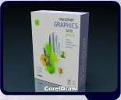
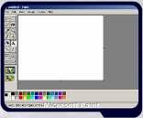
M. Amin, SMK Raja Shahriman

USAGES OF PRESENTATION SOFTWARE
Presentation software is an application that allows users
to create visual aids for presentations to communicate
ideas, messages and other information to an audience.

Examples of presentation software are Microsoft
PowerPoint, StarOffice Impress and CorelDraw.

Some features of presentation software include:
providing a variety of predefined presentation formats that define the
complementary colours for backgrounds, text and graphical accents on
the slides
providing a variety of layouts for each individual slide such as a title
slide, a two-column slide and a slide with clip art, a picture, a chart, a
table or animation
enhancing text, charts and graphical images on a slide with 3-D and
other special effects such as shading, shadows and textures
setting the slide timing so that the presentation automatically displays
the next slide after a preset delay
applying special effects to the transition between each slide
inserting images, video and audio clips

USAGES OF GRAPHICS SOFTWARE
Graphics software is an application that allows users
to work with drawings, photos and pictures. It
provides the users the ability of creating, manipulating
and printing graphics.

Examples of graphics software are Microsoft Paint,
Adobe Photoshop, Adobe Illustrator, Corel Painter and
Macromedia Fireworks.

Some features of graphics software include:
drawing pictures, shapes and other graphical images with various on-
screen tools such as a pen, brush, eyedropper and paint bucket
modifying the contrast and brightness of an image
cropping unwanted objects
removing “red eye”
adding special effects such as shadows and glows

115

